Kinetic Display Assembly Instructions

gobbyo | jbeman@hotmail.com

# Introduction

Complete the assembly of the printed circuit boards (PCB) and electric motor wire soldering.

# Tools

* 3D printer
* Wire Stripper for 28 AWG stranded wire
* Small Philips head screwdriver
* Dupont connector tool
* Soldering station with solder/flux
* Needle nose pliers
* Tweezers
* Clamping tweezers
* Zinc strip or thin metal strip (for melting PLA)
* Wire snipper
* Multimeter
* Breadboard and jumpers for testing electronics
* Label maker (optional)
* Computer with USB connector

# Software

* Git
* VS Code
* Micropython

# Bill of materials

|  |  |
| --- | --- |
| Item | Quantity |
| Single digit PCB for digits 0, 2, & 3 | 3 |
| Controller PCB for digit 1 and the colons | 1 |
| Powerbank PCB | 1 |
| A4 Size Felt Sheets with Adhesive Backing | 1 |
| 2 Inch Jumbo Paper Clips (Smooth Big Paperclips) | 20 |
| M2 x 6mm Stainless Steel Phillips Round Head Self Tapping Screws | 200 |
| M2 x 8mm Stainless Steel Phillips Round Head Self Tapping Screws | 200 |
| M2 X 15mm Stainless Steel Phillips Round Head Self Tapping Screws | 50 |
| Micro 130 DC Motor Strong Magnetic Brushed Electric DC 3V -12V 25000 RPM Cars Toys Electric Motor, High Speed Torque | 30 |
| 28 AWG Gauge Flexible Silicone Rubber Electric Wire | 2 rolls |
| Dupont Jumper Wire Cable Female Pin Connector 2.54mm | 100 |
| 2.54mm 1x2p Dupont Connector Housing Female for Dupont Cable and Jumper Wire | 100 |
| Digital Temperature and Humidity Sensor DHT22 Module, 3 pin | 1 |
| 5mm 0.5 Ω ohm Photoresistor Resistor 5516 GL5516 | 1 |
| 3mm Flat Top LED Diode Lights (Clear Transparent Lens) Bright Lighting Bulb Lamps Electronics Components Indicator Light Emitting Diodes | 114 |
| Vertical Slide Switches Micro High Knob 3 Pin 2 Position 1P2T SPDT Panel Mount AC 125V 2A | 1 |
| 2.54mm 0.1" Pitch PCB Mount Screw Terminal Block Connector, 2P 3P 4P Terminals 150V 6A for 26-18AWG Cable | 1 |
| LM2596 DC-DC Step Down Variable Volt Regulator Input 3.2V-40V Output 1.25V-35V Adjustable Buck Converter Electronic Voltage Stabilizer Power Supply Module | 5 |
| 2.1mm Barrel Jack 5.5x2.1mm Female DC Power Jack 2.1 X 5.5mm DC Jack Connector 6V 9V 12V DC Jack Panel Mount | 1 |
| 12V 5A Power Supply, Waysse Power Supply Adapter, AC DC Converter 100-220V to 12 Volt 5 Amp Transformer 5.5x2.1mm Plug | 1 |
| S8050D S8050 NPN Transistor TO-92 20V 700MA 1W | 1 |
| 1N4001 Diode, standard, 1A, 50V, DO-41 | 1 |
| (optional) 20pin x 10pcs Female Headers Pins Straight Single Row Gold Plated Pitch 2.54mm 0.1 inch for PCB Connector Machine Breadboard Electronic Circuit Board | 10 |
| SONGLE SRS-05VDC-SL 05VDC-SL 4100 Blue 5V 6PIN Power Relay | 1 |
| L293D 16-pin IC Stepper Motor Drivers Controller | 17 |
| 0.1uF Ceramic Disc Capacitor - 50 Volts | 5 |
| 1uF Electrolytic Capacitor 1UF-50V-5X11 | 5 |
| SS8550 TO-92 PNP Transistor | 1 |
| 2N2222 TO-92 - NPN Transistor | 1 |
| 10K ohm Resistor 1/2w (0.5Watt) ±1% Tolerance Metal Film Fixed Resistor | 2 |
| Vertical Slide Switch Micro High Knob 3 Pin 2 Position 1P2T SPDT Panel Mount AC 125V 2A | 1 |
| Raspberry pi 2040 pico | 4 |
| Raspberry pi 2040 pico-W | 1 |
| Superglue (small tube) | 1 |
| White PLA Comgrow 1KG | 2 |
| Black PLA Comgrow 1 KG | 1 |
| Black Easy Nylon Overgure, 1 KG | 1 |
| Black TPU Colorful (flexible), 1 KG | 1 |

Be sure to report any problems with this document by creating a new issue here <https://github.com/gobbyo/kinetic-display/issues>. Title the item "Documentation <section>: <title of your suggested improvement>” and provide details of your suggested improvement.

# Obtain the source code and fabrication files from the kinetic-display GitHub repository

For this task you'll create a fork of the kinetic display repository and clone the fork locally onto your workstation. You’ll need to work with a code fork so that you can modify your local files without changing the original source code. Note this documentation is biased to using the Windows operating system with the latest Git tools.

From your windows machine, install the Git tool set:

1. Open a browser session and go to [Get started with GitHub documentation - GitHub Docs](https://docs.github.com/en/get-started)
2. Click on the link [Creating an account on GitHub - GitHub Docs](https://docs.github.com/en/get-started/start-your-journey/creating-an-account-on-github) to create your account
3. Then [Set up Git - GitHub Docs](https://docs.github.com/en/get-started/getting-started-with-git/set-up-git) to install the Git tool set. Use the default values in the setup wizard.
4. Login with your GitHub account credentials
5. From your browser open <https://github.com/gobbyo/kinetic-display>
6. Click on the "Fork" dropdown and create a new fork
7. Open a command prompt and make a new directory/folder by typing

> mkdir repos

change your command prompt to the new directory using command

> cd repos

This is where you'll clone your forked repo and work from.

1. From your browser, copy the command HTTPS Clone URL and paste it into your command window then hit the enter key. You should see a fork of all the files from the kinetic-display appear in a new folder at “.\repos\kinetic-display\”

Congratulations, you've got the files to begin your project!

Next, we'll send off a request to have the printed circuit boards fabricated.

# Fabricate the Printed Circuit Boards (PCBs)

For this task you’ll order the PCBs. The PCB files are located in your fork at kinetic-display\pcb. See the instructions below to place a separate order for each of the 3 files that begin with the following names:

* Gerber_KineticDisplay-Controller
* Gerber_KineticDisplay-PowerSystem
* Gerber_KineticDisplay-SingleDigit

You’ll need to order more PCBs than required for this project because the minimum order is 5 for most PCB fabrication facilities. Be sure to order the remaining components and materials from the bill of materials (BOM).

1. From your browser open <https://jlcpcb.com/> and create an account if you do not have one, then click the “Order now” button. See the figure below.



1. Open the Gerber file by clicking the “Add gerber file” button. Repeat this step through step 4 for each of the three Gerber files found under the kinetic-display\pcb directory. See the figure below.

1. Use all the default settings except the PCB color. I used white color PCBs as it provides a bit more luminosity to the LEDs.

1. Click the “SAVE TO CART” and finish the order by completing the shipping and payment part of the wizard. See figure below.

It’ll take a few weeks to ship which will be time enough to 3D print the face and parts. You've made it through the most expensive step of this project!

Next, we’ll build the actuators.

# Print display parts

Print all the parts by color and filament type. I prefer to start by printing all the white pieces first, then black. That way no white pieces will be stained from black filament that may have melted onto the nozzle.

## White PLA: Display face, segments, colons, pins, motor mounts, power bank and bumpers

Below are few guidelines to keep in mind when printing and assembling the display face:

* The display face uses over 2/3rds of the 1 KG roll of filament. Therefore, be sure to use the same roll of filament when printing both halves of the display face, segments, and colons. Also, have two 1 KG rolls of white filament from the same batch to avoid inconsistencies in your print color.
* Don’t use any glue as it isn’t necessary and may make a mess.
* Don’t worry if your 3D printer and slicer can’t iron the top surfaces. Ironing the top surfaces is for fit and finish and won’t affect the functionality of the display.
* Be sure you apply an adhesive to the printer plate bed otherwise the edges and corners of the display face may warp. I used all weather Aqua Net, super hold hair spray for my display faces which provided an even coating of adhesive across the entire surface of the bed plate and resulted in nearly perfect corners and edges.

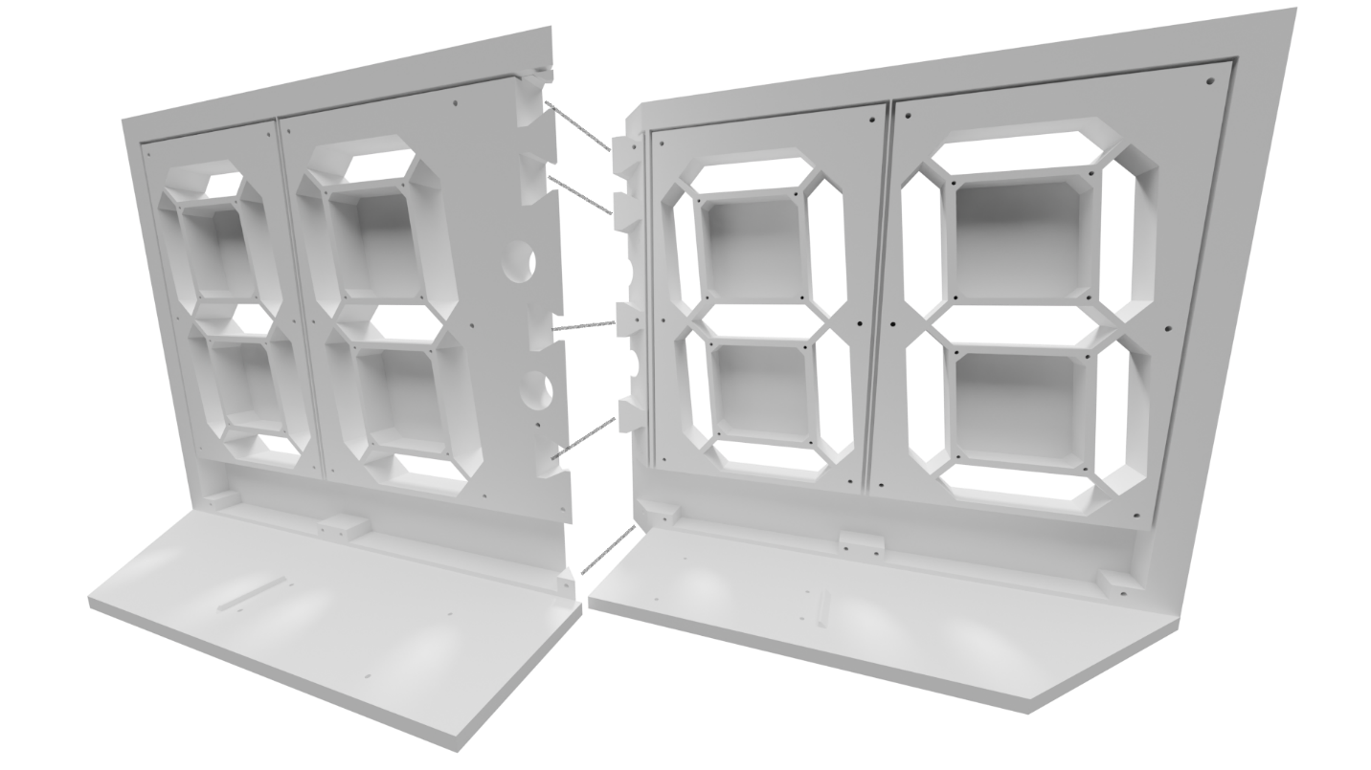

Figure . Back view of the display face

* From the back view of the display face, the left face piece (from left to right) are digits 0, 1 followed by the colons. The right face piece (from left to right) are digits 2 and 3. When viewing the assembled display face from the back, digit 0 is the left-most digit whereas digit 3 is the right-most digit. Consider adding a label above each digit.
* To prevent unwanted warping of the face, allow the freshly printed part to thoroughly cool (at least 30 minutes after completion) before removing it from the printer.

## Black PLA: Motor mount plates and 10-tooth motor shaft gears

## Black TPU: Digit and bumper gaskets

## Black Nylon: Motor rack gear and 30-tooth gears

Table . Nylon gear printer settings

|  |  |  |
| --- | --- | --- |
| File Name | digit-gear30.stl | digit-rack-gear.stl |
| Description | 3:1 reduction gear | Segment rack gear |
| Material | Nylon (PA) | Nylon (PA) |
| Color | Black | Black |
| Size | 1.75mm | 1.75mm |
| Nozzle Temp (C) | 245-260 | 245-260 |
| Quantity | 30 | 30 |
| Per unit (g) | 1.4 | 1.4 |
| Total (g) | 42 | 42 |
| Brand | Overture (Easy Nylon) | Overture (Easy Nylon) |
| Plate | Smooth | Smooth |
| Layer Height | 0.2 mm | 0.2 mm |
| Infill | 100% | 100% |
| Infill Pattern | Rectilinear | Rectilinear |
| Enable Support | No | No |
| Ironing | None | Top Surfaces |

The digit-rack-gear and digit-gear30 have a critical role in the proper functioning of the actuator and must not be warped or stringy. Either condition will cause the actuator to function poorly or not at all.

Note that in the creation of my prototype I used black Overture Easy Nylon. Nylon won't print correctly unless it is dried in a filament dryer for around 48 hours. Some indicators of damp filament include prints that are stringy or the fine points like the teeth on each gear may not be well defined, it’ll have blobs of filament accumulate at the nozzle exit points of the part and have interconnected strings of filament where the nozzle head has travelled.

The nylon gears must be printed on either a smooth PEI plate or directly onto a glass bed to ensure smooth movement. Bed adhesion can be difficult to achieve on smooth surfaces or glass. In this tutorial I'll show you a few tips to get a good print with nylon.

Have the black nylon filament dried and loaded into your printer and ready before starting this tutorial. Be sure to use a clean sponge and scrub your build plate with dish soap, thoroughly rinse and dry, then apply a thin layer of all-weather Aqua Net, super hold hair spray onto the build plate. Liberally spray the hairspray across the entire top surface of the build plate and spread it using the edge of a paper towel to ensure even coverage.

1. Load the digit-gear30.stl into your slicer.
2. Load the digit-rack-gear.stl into the same build plate as the previous step.
3. Use the settings provided in the table above
4. Clone 29 more of the digit-gear30.stl parts. NOTE: You may want to run a test print of each part and skip this step 4 through step 6 before printing all 30 parts.
5. Clone 29 more digit-rack-gear.stl parts
6. Evenly space (auto space) the models across the build plate
7. Slice the plate
8. Send the parts to the printer.
9. Let the parts sit and cool on the build plate for at least 60 minutes before removing them after the print is complete. The parts should be at room temperature before removal. Prematurely removing the rack gears when warm or even slightly warm will cause them to warp and produce poorly functioning actuators.

Don't compromise on the quality of your print. Be sure to reprint the parts until you get good results.

Congratulations! You are ready to go onto the next step to print the 10-tooth gear for the motor shaft using black PLA.

# Actuator assembly

There are 30 actuators in the display, 7 per digit and 2 for the colons (4 digits x 7 segments + 2 colons = 30 total actuators). The diagrams below identify the various parts and composition of the actuator.

Figure . Fully assembled actuator with segment and back bumper.

Figure . Actuator rack and pinion gear assembly

## Mount the gear onto the motor shaft of the Micro 130 DC 3V -12V High Torque Magnetic Brushed Electric Motor.

|  |  |
| --- | --- |
| Here is what you’ll need |  |
| 1. Place a drop of super glue into the hole of the 10-tooth gear |  |
| 1. Insert the gear onto the top of the shaft and press down using the flat of a screwdriver, forcing the gear down the shaft until it stops about 3mm shy of the end of the gear. |  |

## Prepare the motor mount for assembly

Cut 30, 20mm shafts from the straight sections of large paper clips. Following the diagram below, discard the motor mount section in red.

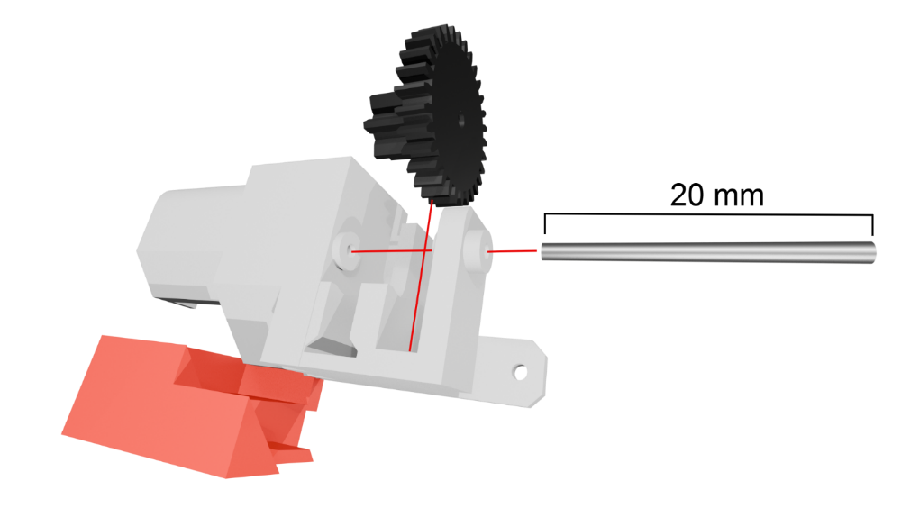

Figure . Motor mount assembly with 20mm shaft, the red support section is discarded

### Motor mount step-by-step assembly

|  |  |
| --- | --- |
| 1. Print the motor mount and 30 tooth gear. Using wire cutting pliers, cut a 20mm length of shaft from a large paper clip. | A plastic gear, motor mount, and metal shaft on a cutting mat |
| 1. Feed the shaft into the outer collar of the motor mount. Have about 0.5 mm protruding through the inside of the outer collar. | A close-up of the metal shaft being inserted into the motor mount |
| 1. Align the 30-tooth gear with the shaft, having the large gear facing out and the small gear on the inside. Slide the shaft all the way into the motor mount so that it countersinks 1mm into the outer collar. | Assembled motor mount on a cutting mat |
| 1. Heat up your soldering iron to 250ºC and melt the outer collar over the end of the shaft to prevent it from working out of the motor mount. | Preparing the assembled motor mount collar to be melted by a soldering iron |
| 1. The half-melted collar forms a permanent hold for the motor mount shaft and 30-tooth gear. Note that I melted the outer collar using a small zinc strip (any thin piece of metal will do) held by clamping tweezers. Once complete, the 30-tooth gear should move freely back and forth by pushing it with your finger but should not move side to side nor freely spin. | A fully assembled motor mount with the outer collar melted to held the metal shaft in place |

## Prepare the brushed DC 3-10v motors

Label 4 of the DC motors with the letter “C” and another 4 DC motors with the letter “D”. The CW (clockwise) and CCW (counterclockwise) wires from these motors will need to be 6 cm in length. The rest of the motors will use 4 cm length wires.

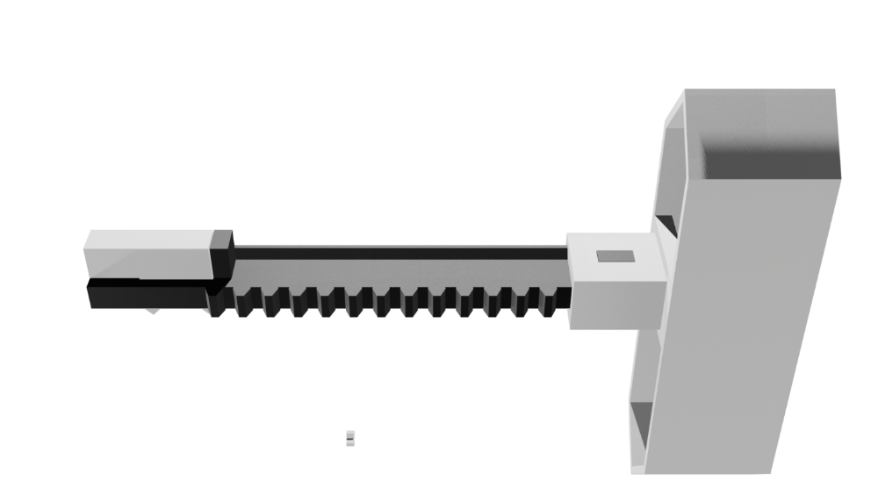

# Print and assemble the display face

Print the display faces following the table of 3d printer settings below and press the two pieces together as diagrammed in figure 1.

Table . Display Face FDM settings

|  |  |  |
| --- | --- | --- |
| File Name | face-digit0-1.stl | face-digits2-3.stl |
| Description | Right side of display face  (when viewed from front) | Left side of display face  (when viewed from front) |
| Material | PLA | PLA |
| Color | White | White |
| Size | 1.75mm | 1.75mm |
| Temp (C) | 190-210 | 190-210 |
| Quantity | 1 | 1 |
| Per unit (g) | 340 | 315 |
| Plate | Smooth | Smooth |
| Layer Height | 0.2 mm | 0.2 mm |
| Infill | 50% | 50% |
| Infill Pattern | Grid | Grid |
| Enable Support | Yes | Yes |
| Ironing | Top Surfaces | Top Surfaces |

# Gasket and Digit PCBs Assembly

Print the gaskets and assemble with the PCBs using M1.7x8mm self-tapping screws. Each digit PCB will have two, 28 AWG stranded wires that need to be long enough to reach its corresponding buck converter.

Table . Digit gaskets FDM settings

|  |  |  |
| --- | --- | --- |
| File Name | digit-colon-gasket.stl | digit-gasket.stl |
| Description | Colon/Digit PCB gasket | Digit PCB gasket |
| Material | TPU | TPU |
| Color | Black | Black |
| Size | 1.75mm | 1.75mm |
| Temp (C) | 190-210 | 190-210 |
| Quantity | 1 | 3 |
| Per unit (g) | 39 | 20 |
| Total (g) | 39 | 60 |
| Brand | Colorful (Flexible) | Colorful (Flexible) |
| Plate | Smooth | Smooth |
| Layer Height | 0.2 mm | 0.2 mm |
| Infill | 50% | 50% |
| Infill Pattern | Grid | Grid |
| Enable Support | No | No |
| Ironing | None | None |

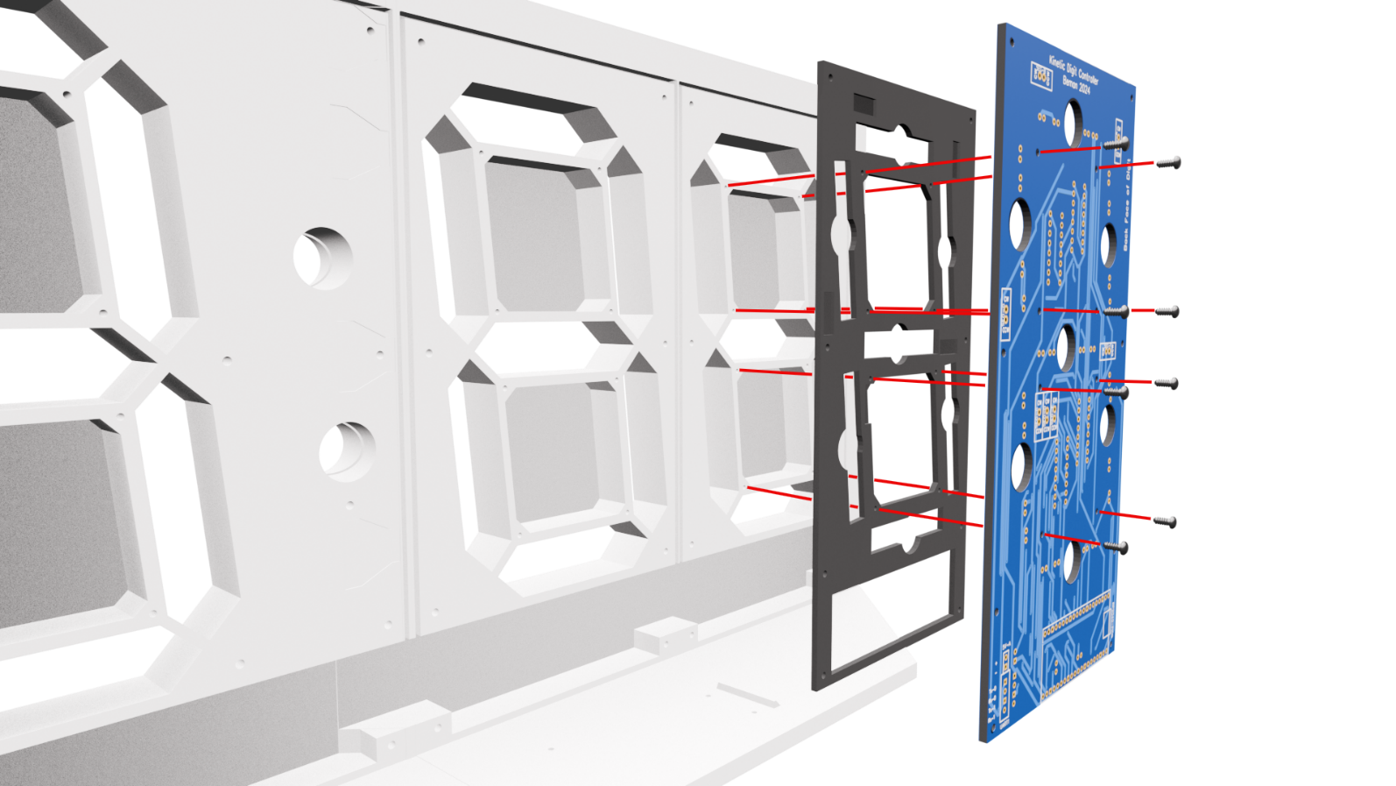

Figure . Add digit 0, 2, and 3 gaskets and the digit PCBs* to the back of display the face

*Note this diagram doesn’t display the PCB completed with the components soldered onto the board. At this stage you should have completed the soldering and testing of all components onto the PCBs.

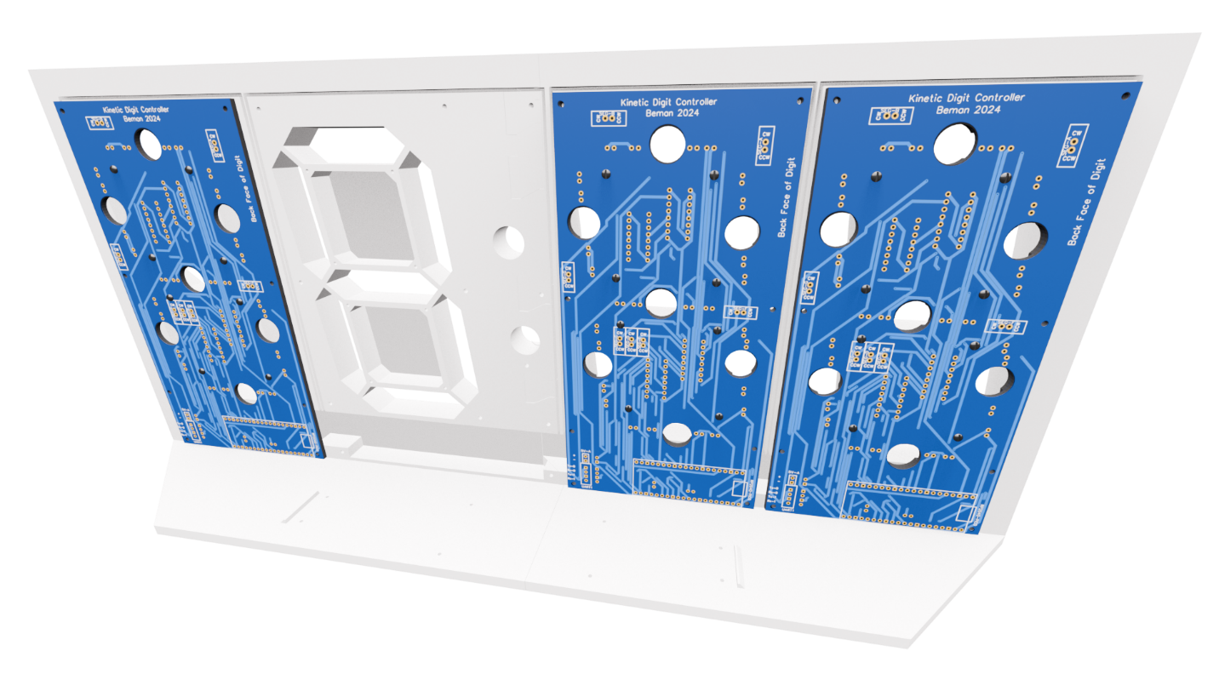

Figure . Back of the display showing assembled digits 0, 2, and 3 with gaskets

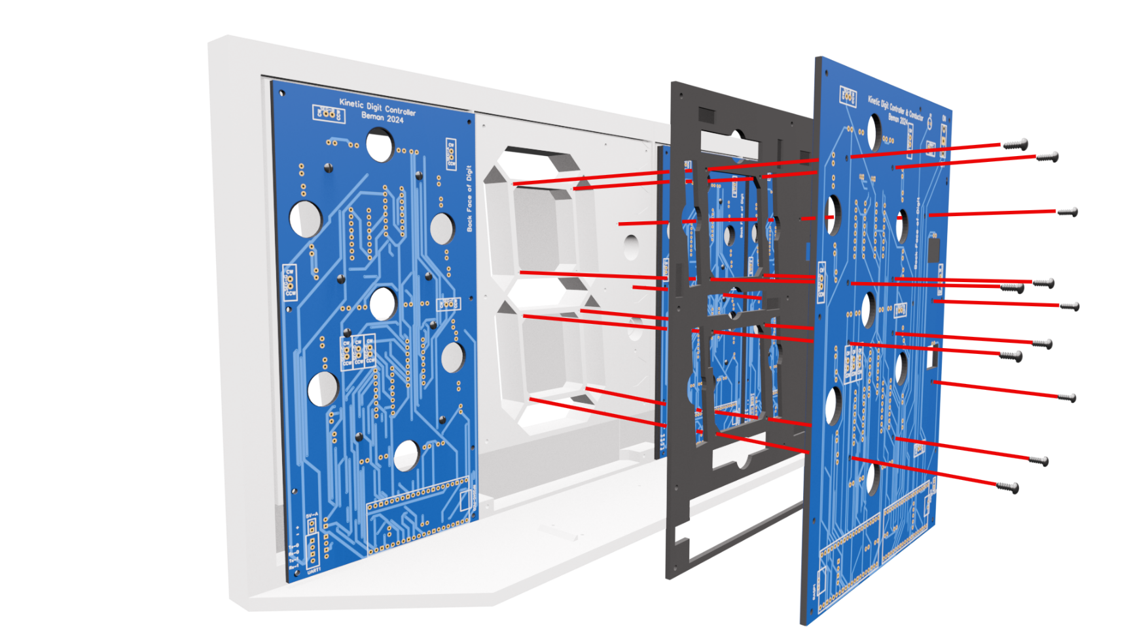

Figure . Back of the display showing the assembly of digit 1 and colons with gasket

# Schematics for Digits 0, 2 & 3

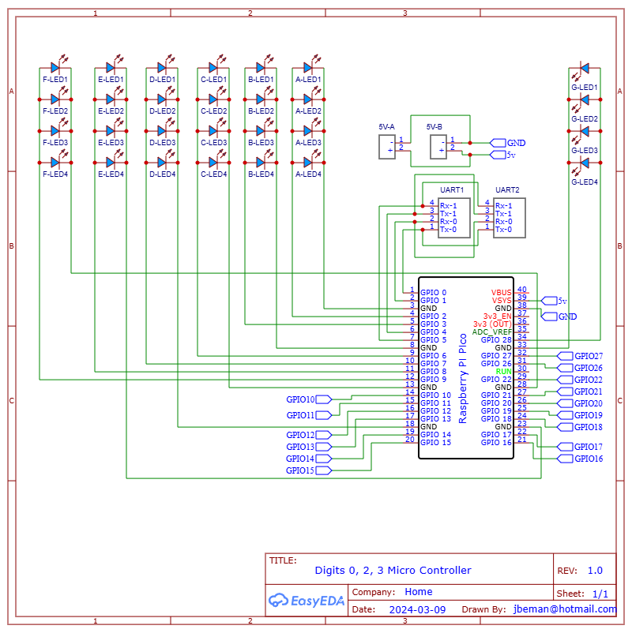

Figure . Schematic for Digits 0, 2, 3 Microcontrollers

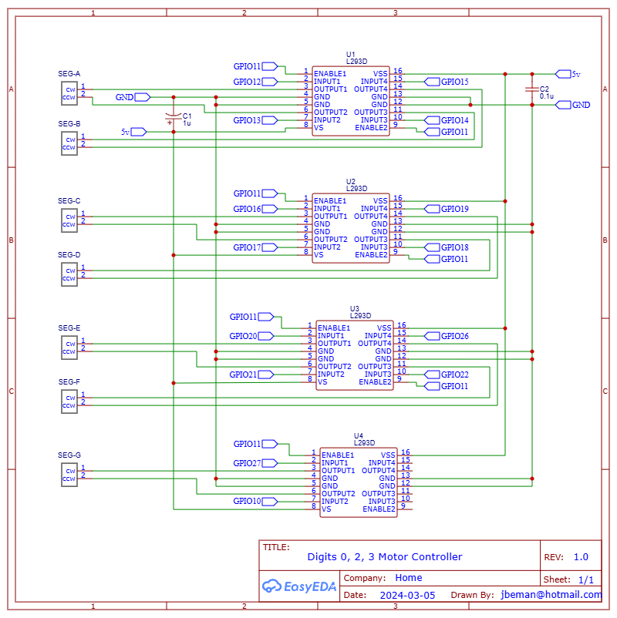

# PCB for Digits 0, 2, 3

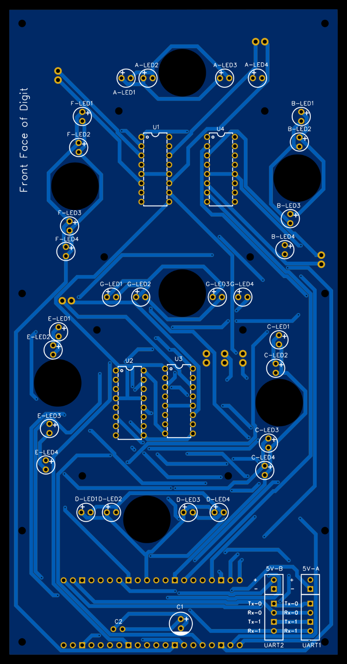

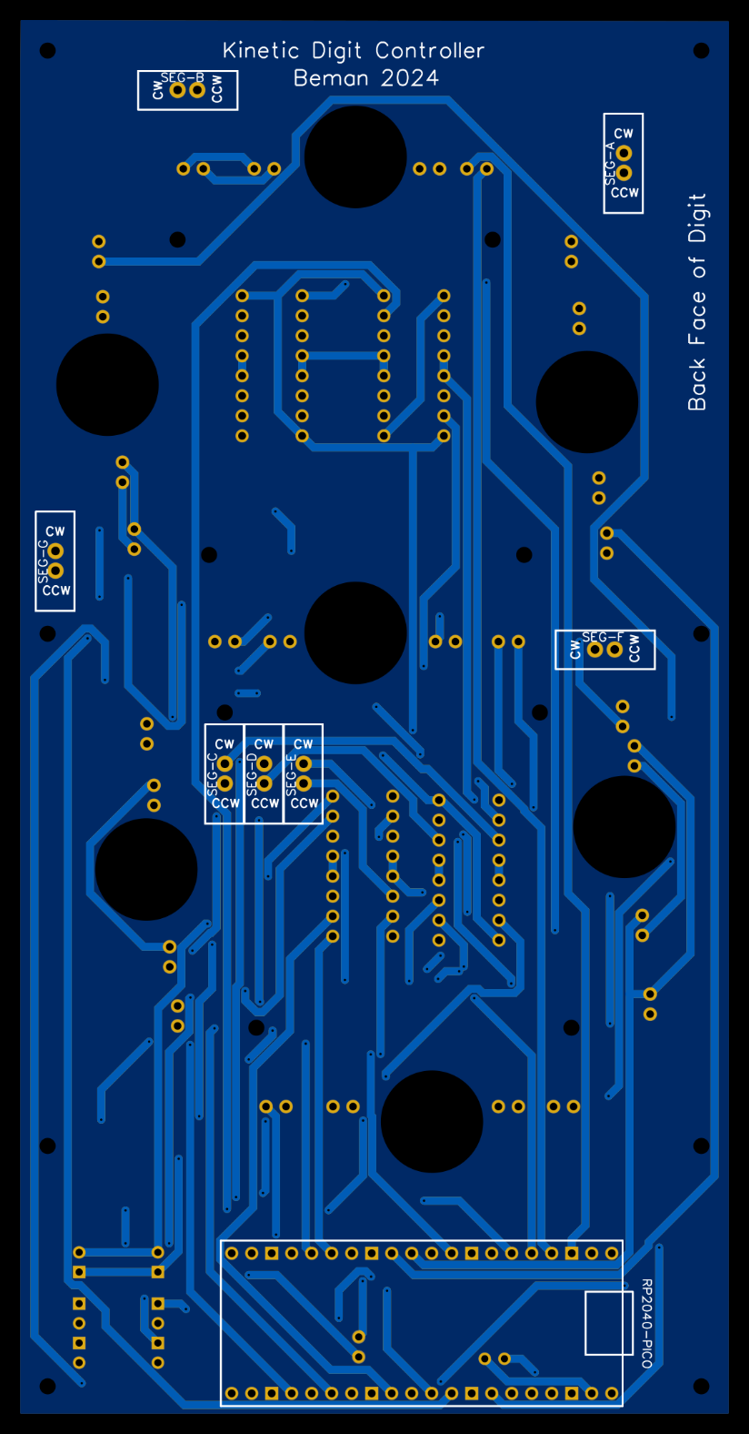

# Schematics for Digit 1 and Colons

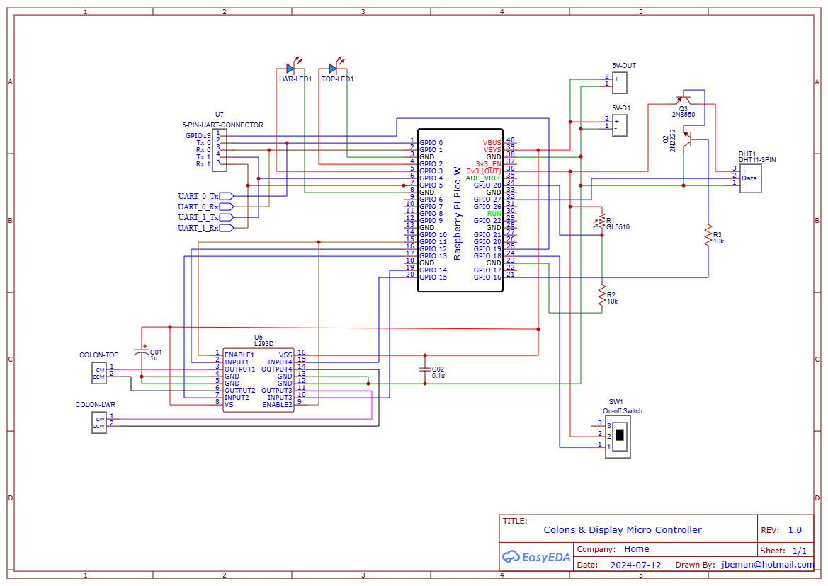

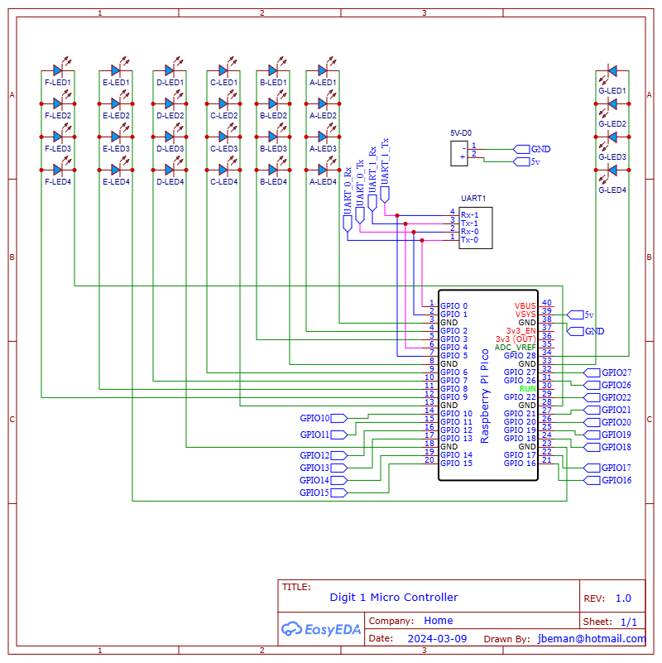

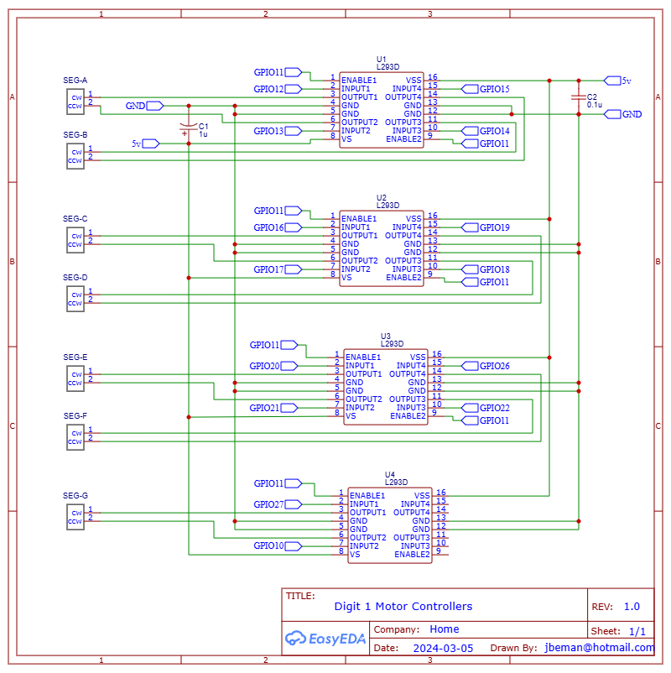

# PCB for Digit 1 & Colons

